
Story

Date | 27 October 2026
Team ID | Individual
Project Name | Global Olympic Sports Performance Analysis
Maximum Marks | 5 Marks

By using stories in Tableau, you can effectively communicate complex data in a way that is both interactive and engaging, making it easier for the audience to follow along and understand the insights. It’s a tool for data storytelling, allowing you to present insights in a cohesive, engaging way that takes viewers through a logical progression of findings or analyses.
In Tableau, Story is a feature that allows you to create a sequence of dashboards, visualizations, and text to present data insights in a cohesive and narrative-driven way. It's like a slideshow within Tableau that guides the audience through a series of data points, helping them understand key insights, trends, or outcomes of your analysis.

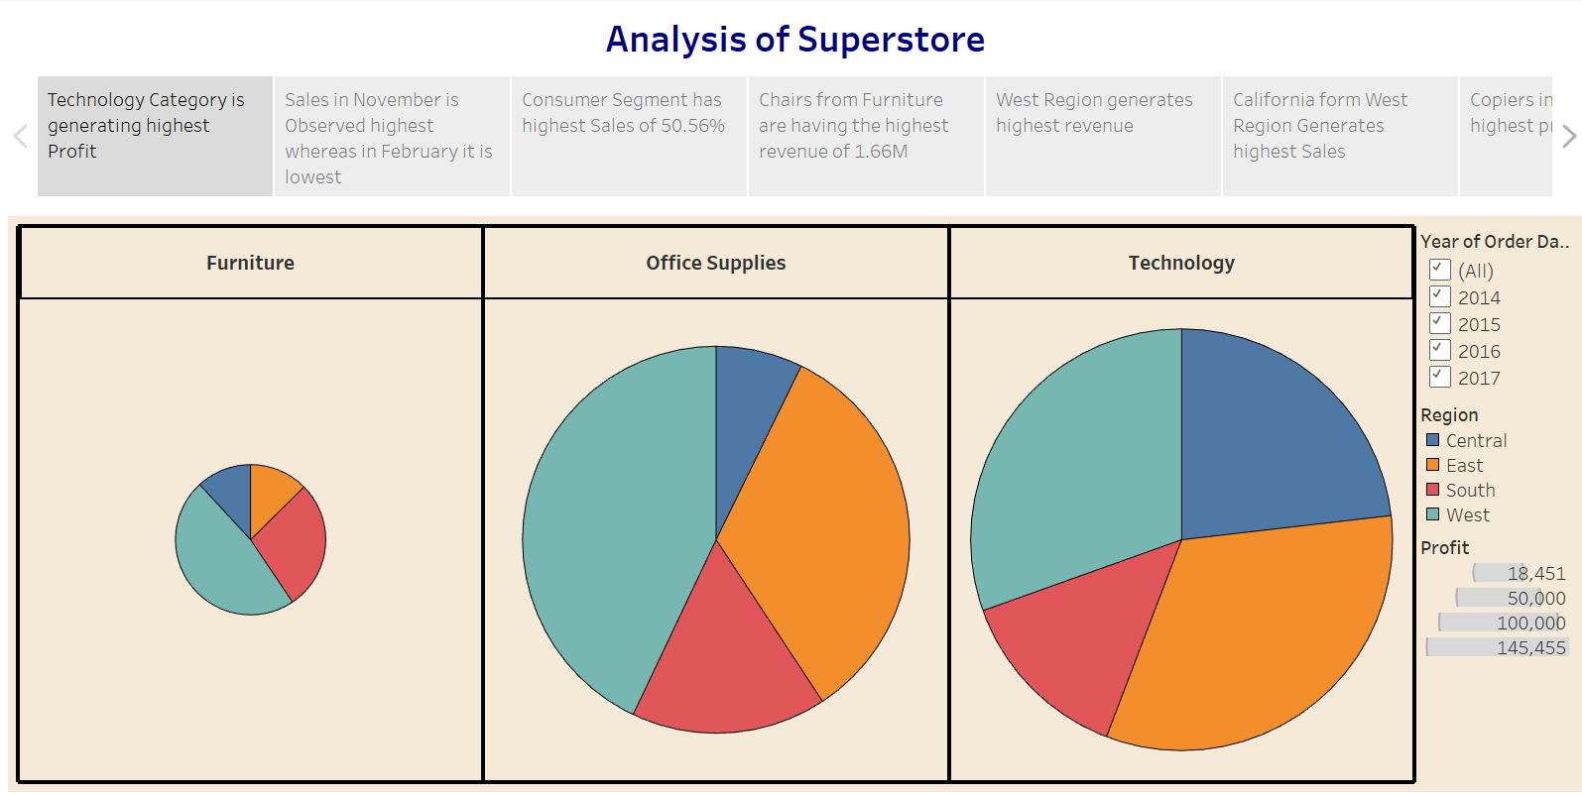

Observations:
- Technology Category Leads in Profit: The Technology category is generating the highest profit among all categories.
- Seasonal Sales Trend: Sales peak in November, while February sees the lowest sales, indicating a possible seasonal trend.
- Consumer Segment Dominates: The Consumer segment contributes to the highest percentage of sales, accounting for 50.56%.
- Top Revenue-Generating Product: Chairs from the Furniture category generate the highest revenue, totaling 1.66M.

Activity 2:
Publish Story on Tableau Public and Paste Public link below
https://public.tableau.com/views/SalesStory_17247663658720/Story1?:language=en-US&:sid=&:redirect=auth&:display_count=n&:origin=viz_share_link
Story Title
Global Olympic Sports Performance: Country Strength, Regional Patterns, and Historical Trends
Story Point 1 — Global Performance
Use Dashboard 1 to explain overall country rankings, medal composition, Summer/Winter comparison, and average medals per athlete record by sport category.

Story Point 1 — Scenario 1: Ms. Priya, National Olympic Committee Performance Strategist
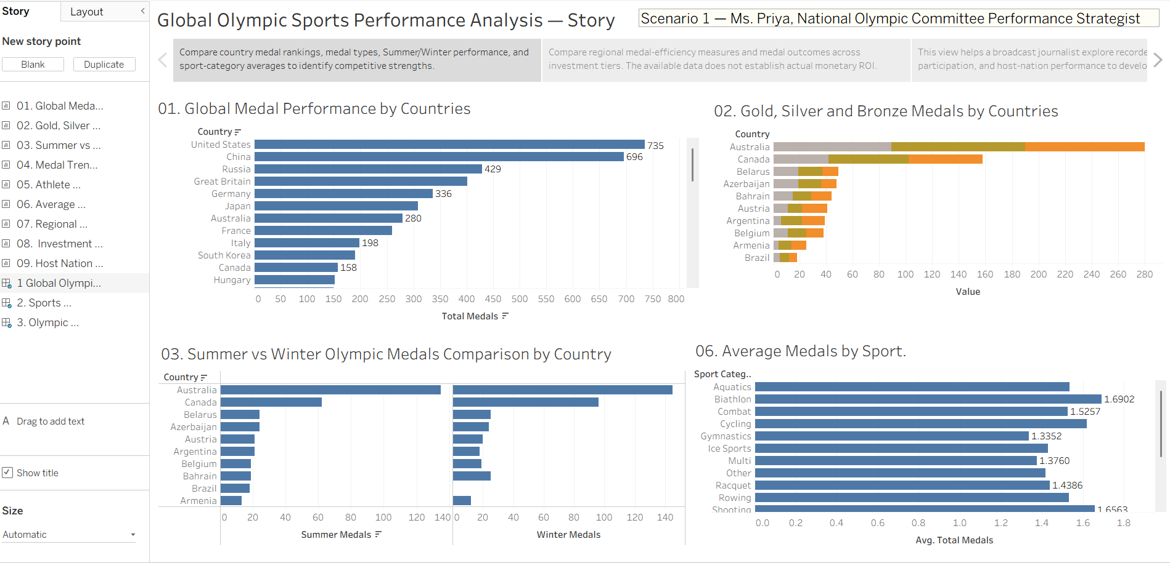
Story Point 2 — Investment and Regional Efficiency
Use Dashboard 2 to compare recorded efficiency metrics by region and average medal totals across investment tiers. State that investment is categorical (High/Medium/Low), so monetary ROI cannot be calculated from these files.
Story Point 2 — Scenario 2: Mr. Carlos, Sports Investment Analyst at an International Funding Agency
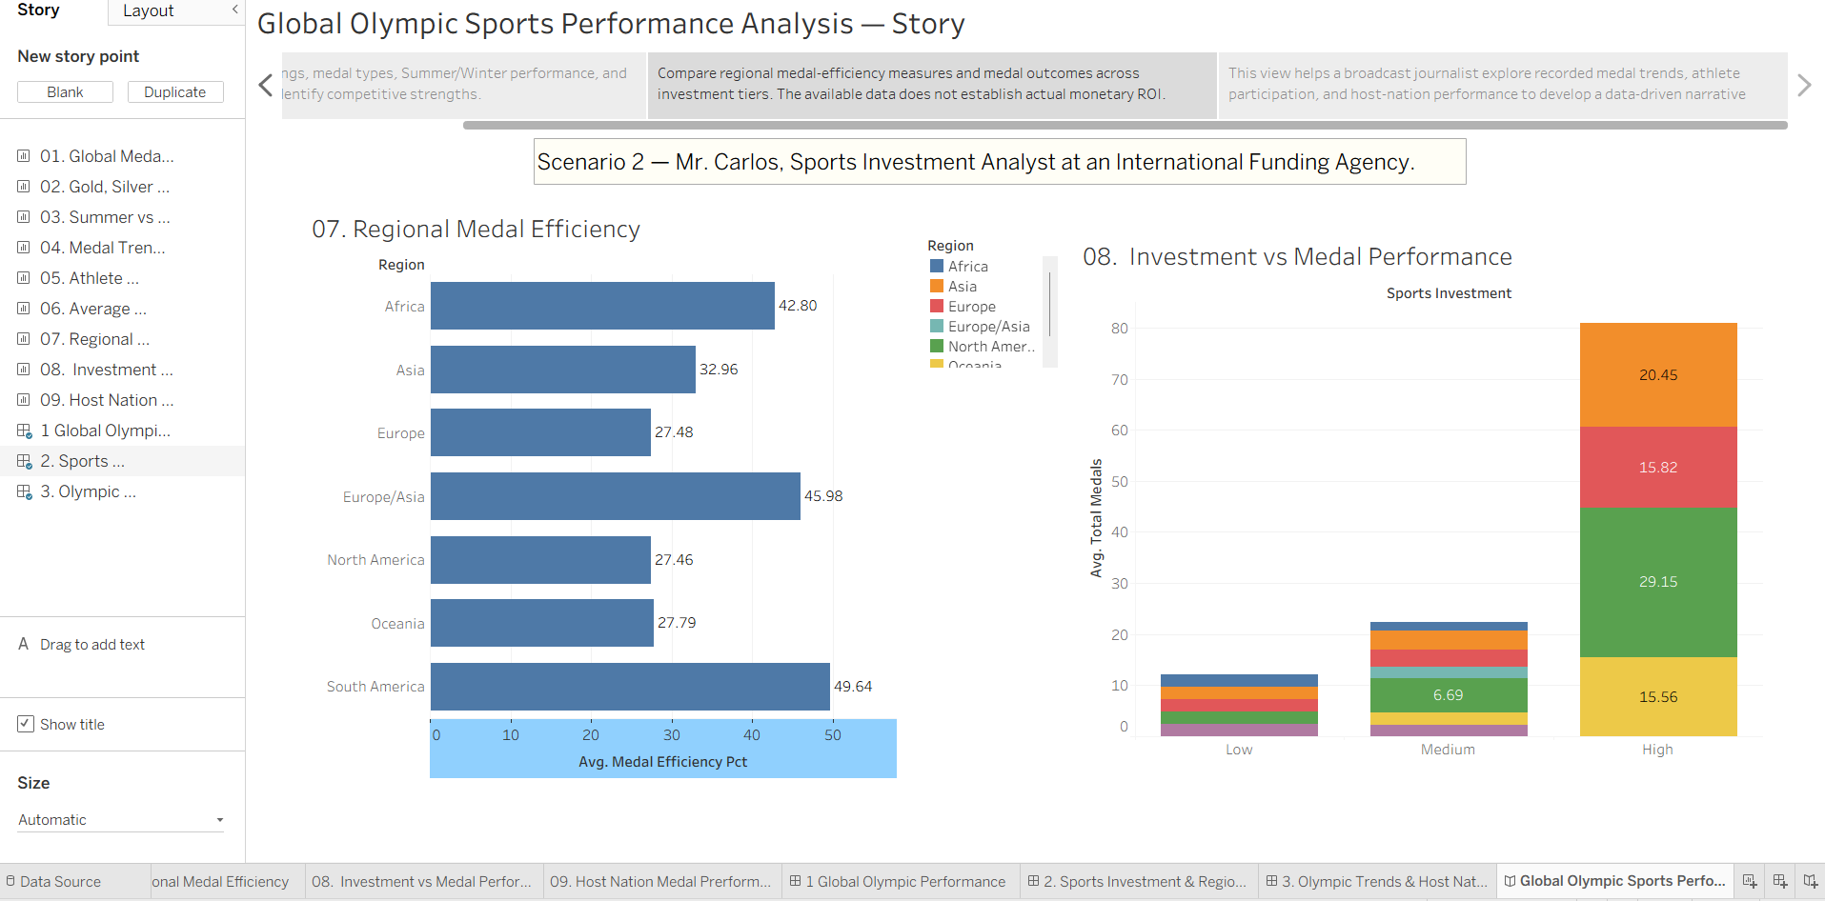
Story Point 3 — Trends and Hosts
Use Dashboard 3 to discuss recorded medal trends, athlete participation, and host-nation medal performance. Clearly identify dataset-recorded values and do not present unverified rows as official results.
Story Point 3 — Scenario 3: William Robert, Broadcast Journalist and Data Storyteller
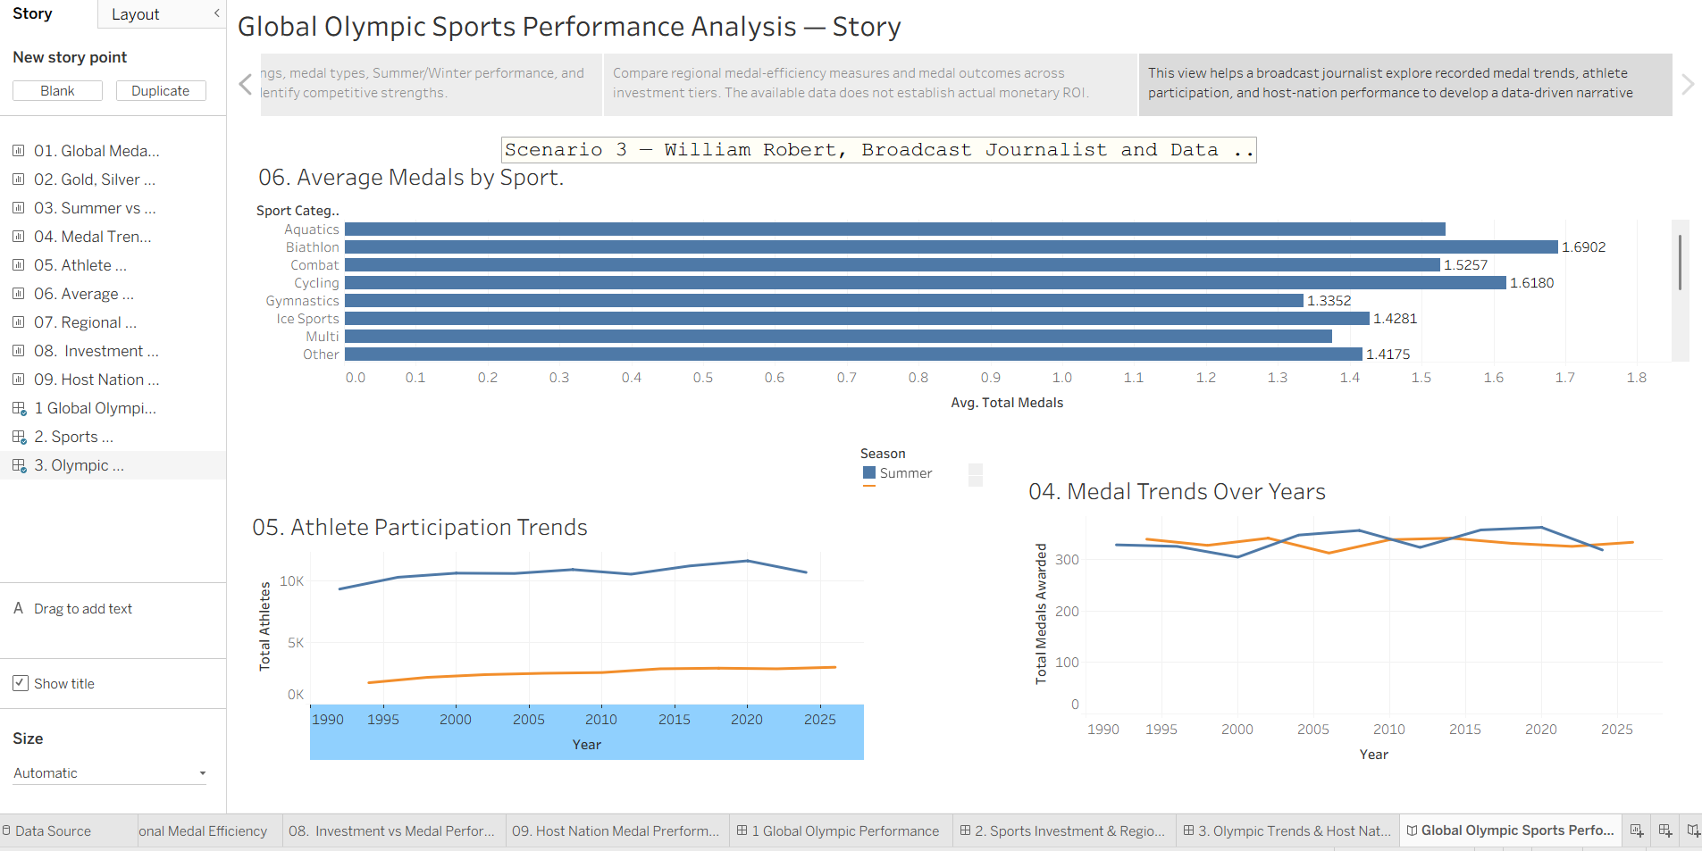
Observations
• United States (735 medals) and China (696) lead the all-time country ranking, well ahead of Russia (429) and Great Britain (401).
• Among sport categories, Biathlon (1.6902), Shooting (1.6563) and Cycling (1.6180) give the highest average medals per athlete record; Sliding (1.3098) is the lowest.
• South America records the highest average medal-efficiency value (49.64), followed by Europe/Asia (45.98) and Africa (42.80); Europe, North America and Oceania are all near 27–28.
• Medals in the High investment tier are far higher than in the Medium and Low tiers; investment is categorical, so this does not represent monetary ROI.
• Medals awarded per Games stay in a narrow band of about 305–363; the Summer low is in 2000 (about 305) and the peak is Summer 2020 (about 363), with Winter 2026 at about 334.
• Summer Games have roughly 9K–12K athletes versus about 2K–3K for Winter, and Winter participation has risen steadily since 1994.
Tableau Public Story Link
https://public.tableau.com/views/olympic07/GlobalOlympicSportsPerformanceAnalysisStory?:language=en-US&publish=yes&:sid=&:redirect=auth&:display_count=n&:origin=viz_share_link

